Senior Capstone Project: Preview
As part of the school curriculum for engineering students at Embry-Riddle, all seniors in the program must complete a Capstone project. These projects are two semesters long and consist of preliminary design and detailed design. As an undergraduate student, they are an excellent way to tackle real-world engineering problems in a way that resembles what soon-to-be graduates will experience in industry. Capstone projects are completed in groups ranging anywhere from 5 to 15 students.
During the preliminary design phase, students are tasked with developing project requirements, performing trade studies, and delivering design reviews to name a few of the many steps in the design process. Although some teams must come up with their own ideas for capstone projects, my team was fortunate enough to receive a sponsorship from Honeywell Aerospace. They approached us with a proposal to create a test rig so that the lifespan of a foil bearing used in a gas turbine engine can be estimated.
To give some basic background on the project, foil bearings are contactless while spinning, and rely on a thin film of high-pressure air to keep the shaft suspended and constrained. Surrounding the shaft is a series of foils, which are thin metal sheets bent into various shapes depending on the application. Given ingestion of small, high velocity particles over time, these foils are subjected to wear due to abrasion. Hence the need to determine the engine runtime before these bearings need to be repaired or replaced.
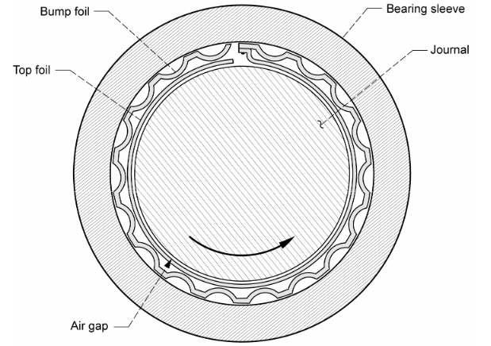
Diagram of a Basic Foil Bearing
(Source: ntrs.nasa.gov/api/citations/20050160253/downloads/20050160253.pdf)
We were given a document from Honeywell detailing the “why” of this test rig and giving basic requirements. Throughout the course of our meetings with our engineering contact at Honeywell, we have ascertained more about what the company requires of the machine and have developed a comprehensive set of high-level stakeholder requirements for the project.
Given Honeywell’s needs, we created a block diagram of the system which included the main subsystems and how each of them interface with each other. This includes basic high-level components and connections. I then created several mathematical models in Matlab to validate whether our initial layout and assumptions would work. These include parameters like power required to heat the inlet air, torque required to maintain our target speed, and so on. We use the outcomes of these models to size components and refine our system architecture.
With a basic system layout established, we are now moving on to conducting trade studies on various components required for the project. These include components like seals, motors, heaters, various controllers, and much more! The goal of these trade studies is to further refine our system based on several criteria including cost, safety, reliability, and ability to meet project requirements.
While I wish I could talk more about what makes this project so awesome, I appreciate you for taking the time to read a little bit about my Capstone project and be sure to check back for future updates!

